BLOGNEST API
Professional Project Submission
Node.js • Express.js • MongoDB • Gemini AI
Role | Team Member
Team Leader | Charulatha D
Member | Ragavi SR
Member | Sandhiya S
Member | Yuvashree R G
Member | Arokiya Felci
1. Introduction
BlogNest API is a backend application developed to provide a structured REST API for blog-related operations. The project uses Node.js and Express.js for the server layer, MongoDB for data storage, and Gemini AI services for AI-assisted blog functionality.
The application is organized into routes, controllers, middleware, models, configuration, and services, making the backend modular, maintainable, and easy to extend.
2. Objective
The main objective of BlogNest API is to build a reliable backend service for managing blog content and user authentication while supporting AI-assisted features. The API processes client requests through appropriate routes and controllers, interacts with MongoDB, and returns structured responses.
3. Project Overview
Backend | Node.js with Express.js
Database | MongoDB
Authentication | JWT-based authentication
AI Integration | Gemini AI service
API Style | RESTful API endpoints
Structure | Routes, controllers, middleware, models and services
4. Key Features
- User registration and login.
- Protected profile access using authentication middleware.
- Blog data retrieval and management through REST API endpoints.
- AI-assisted blog functionality using Gemini AI.
- MongoDB integration for persistent application data.
- Modular backend structure for easier maintenance.
5. Project Structure
The project follows a modular structure with separate folders for configuration, controllers, middleware, models, routes, and services. The main application and server files are maintained at the source level, while environment variables are kept separately for configuration.

6. Project Screenshots
The following screenshots show the project configuration and a successful API response.
6.1 Project Configuration and Server
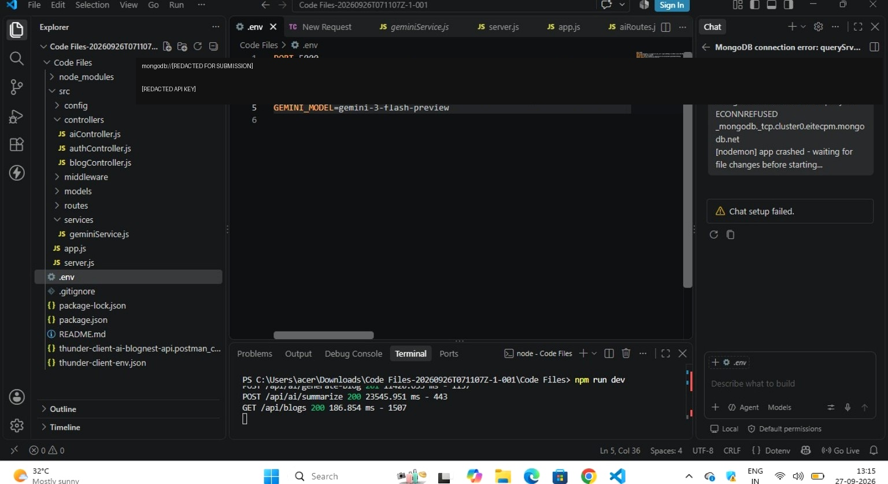
Sensitive credentials are redacted for safe submission.
6.2 Blog API Response
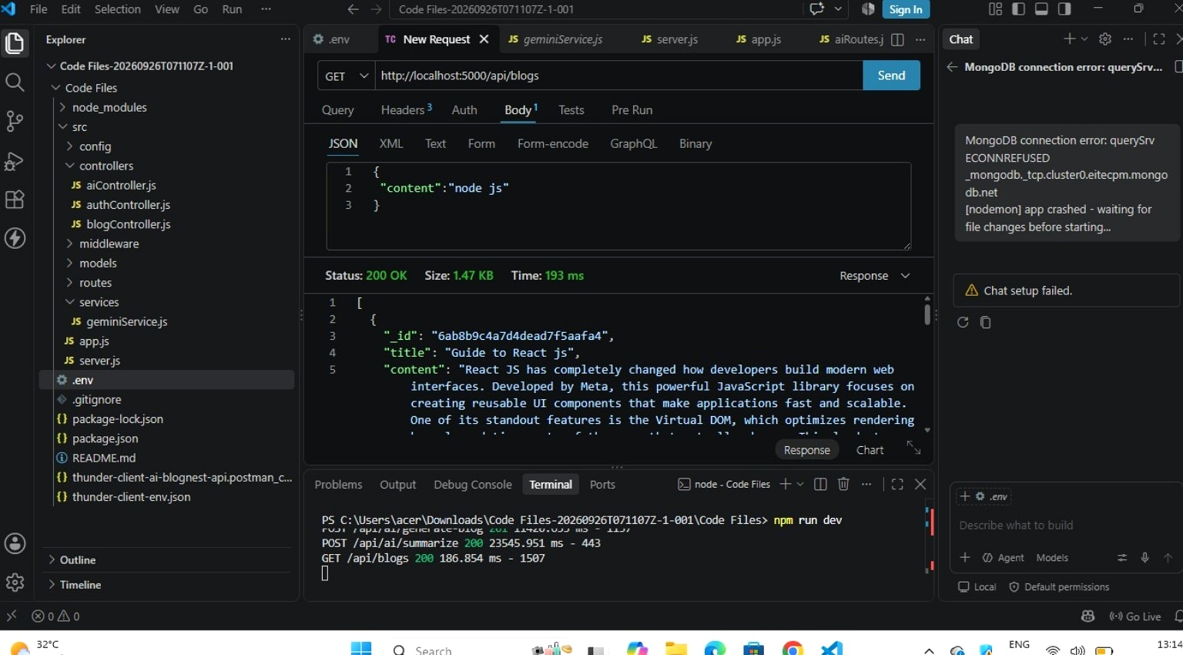
API client showing a successful 200 OK response from the blog endpoint.
7. Conclusion
BlogNest API provides a structured backend foundation for a blog application, combining RESTful services, authentication, MongoDB data storage, and Gemini AI integration. Its modular architecture supports further development and frontend integration.

